2016/6116/9128 - 2048x8 bit Static RAM

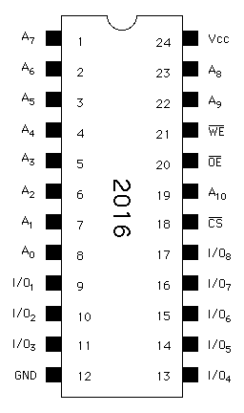 | Description  The 2016/6116 series of Static RAMs are 16,384 bit memories organized as 2,048 words by 8 bits and operates on a single +5V supply. 2016's and equivalents are generally NMOS or MOS process parts, where the 6116 and compatibles are built from CMOS technology. All provide three state outputs, are TTL compatible, and allow for direct interfacing with common system bus structures.
  Access Time
  25 to 450ns depending on part speed grade
  Fully TTL compatible
  Three-State Outputs
  Single Supply (Vcc = +5V +-10%)
  Fully Static Operation, no clock or refreshing required
  Current varies from 10-100mA, CMOS versions are generally lower power
  Standby power (deselected chip) varies from 1-100uA
Pin Names
A0 - A10 Address Inputs
I/O1 - I/O8 Data Input/Outputs
CS* Chip Select Input (Active LOW)
WE* Write Enable Input (Active LOW)
OE* Output Enable Input (Active LOW)
Vcc Power (+5Vdc)
GND Ground (0Vdc)
Operating Characteristics
Vcc = 5V +- 5%
GND = 0V
Supply Current = 10 to 100mA depending on manufacturer and fabrication process
Read Timing (Standard 6116-90)
Chip Select Access Time = 90ns min
Chip Deselect Access Time = 40ns max
Write Timing (Standard Grade)
Write Cycle Time = 90ns min
Write Pulse Width = 55ns min
Address Setup Prior to Write = 0ns
Chip Select to End of Write = 55ns min
Write Recovery Time = 0ns
Used In
Bally/Midway - TRON, Two Tigers, Kickman, Satan's Hollow, Timber, Wacko, etc.
Sega - Championship Baseball, etc.
Capcom - Ghosts and Goblins, etc.
Atari - Dig Dug, Xevious, etc.
Cross-references to
2016/6116:
Hitachi HM6116, HM6116L
Fujitsu MB8416A
NEC uPD446
Mitsubishi 5M5517, M58725
Mostek MK4802
Motorola MCM4016, MCM65116
Texas Instruments TMS4016
Toshiba TC5517, TMM2016
OKI MSM5128, MSM2128
Sony CXK5816
Sieko/Epson SRM2016
Sharp LH5116
Synertek SY2128
Can substitute:
2016 and 6116 parts can generally be substituted for each other. Be careful to note if the device will serve as battery-backed memory for parameters, high scores, etc. If so, use a CMOS (6116) series part for longer battery life.
In a pinch, Cache RAM can be substituted (the extra speed Cache RAM provides will not be utilized, but if you have some in your parts-box...) although it's usually in a "skinny dip" type package (0.3" wide).
6116 compatible Cache RAM:
Cypress CY7C128
IDT IDT6116A
Vitelic V61C16
Micron VT20C19
Sony CXK5814P
Toshiba TC2018
Motorola MCM2018A
Hitachi HM6716
Source of information
Fairchild Bipolar Memory Data Book, 1983
Fujitsu Microelectronics Memory Data Book, 1982
United Microelectronics Corporation Memory IC's Data Book, 1990-1991
NEW Electronics Inc. Memory Products Data Book, 1985

http://www.engcomp.pucpr.br/afonso/Datasheet/2016.html

